This is my
Hospital Passport
For people with a cognitive impairment coming into hospital
My name is:
If I have to go to hospital this book needs to go with me, it gives hospital staff important information about me.
It needs to hang on the end of my bed and a
copy should be put in my notes.
This passport belongs to me. Please return it when I am discharged.
Nursing and medical staff please look at my passport
before you do any interventions with me.
Things you must know about me
Things that are important to me
My likes and dislikes
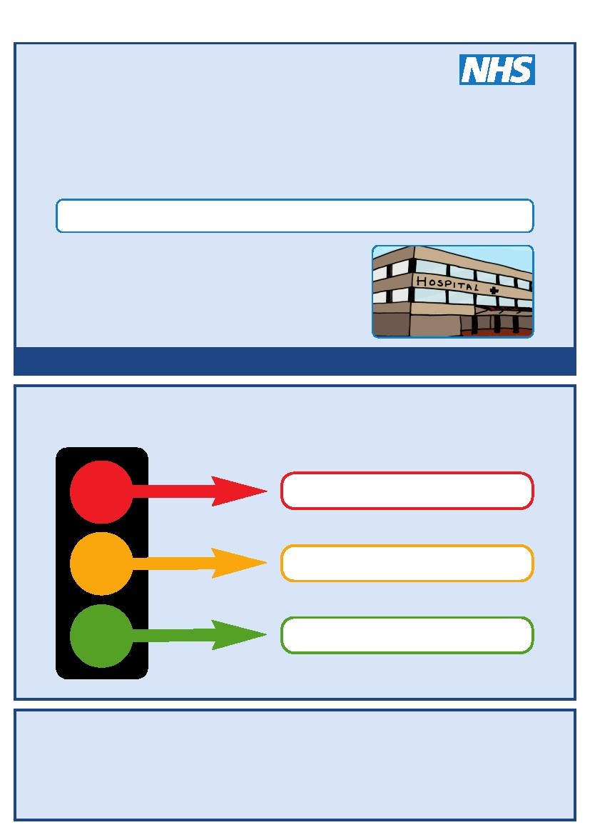

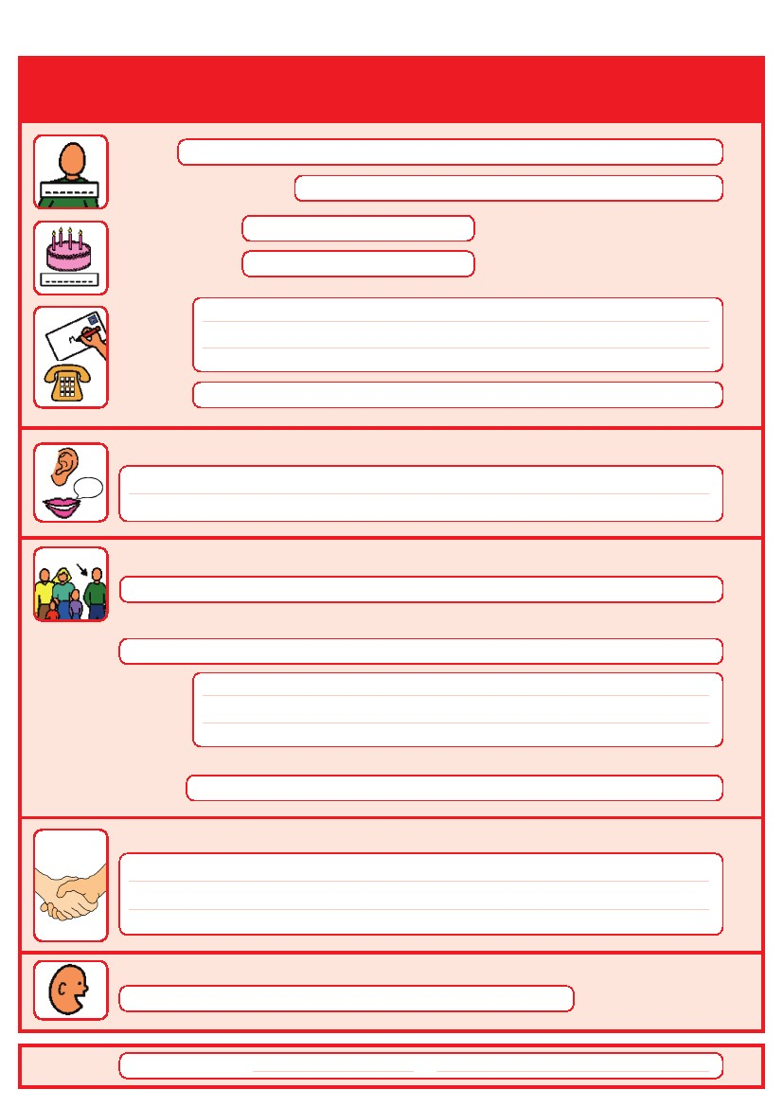
Things you must know about me
Name:
Likes to be known as:
NHS number:
Date of Birth:
Address:
Tel No:
How I communicate/What language I speak:
Family contact person, carer or other support:
Relationship e.g. Mum, Dad, Home Manager, Support Worker:
Address:
Tel No:
My support needs and who gives me the most support:
My carer speaks:
Date completed
by
1
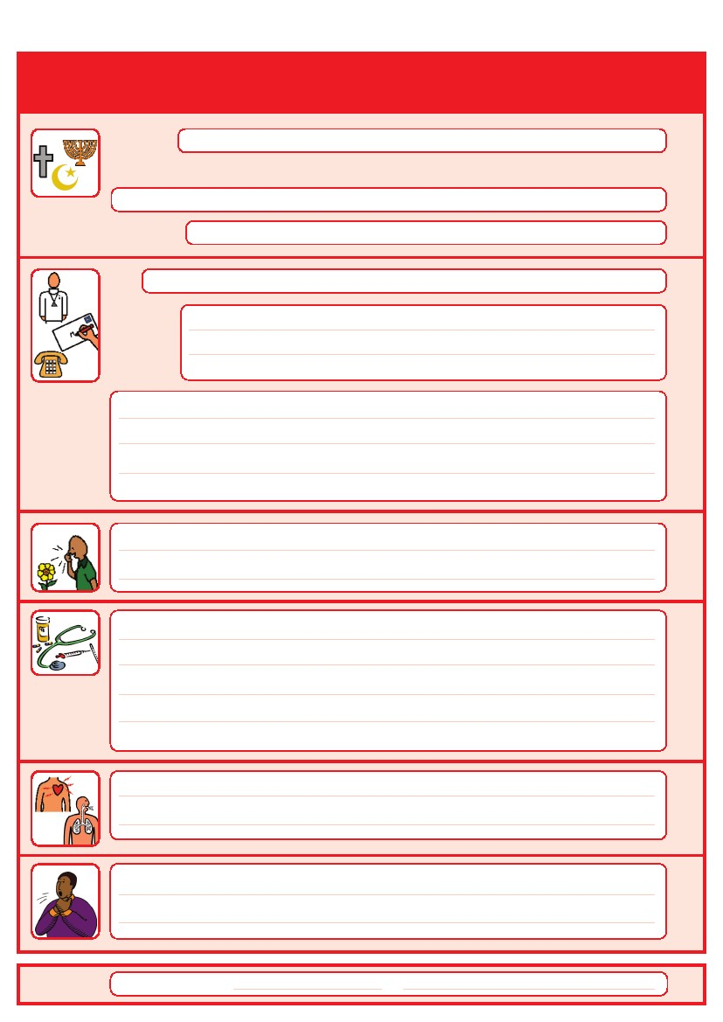
Things you must know about me
Religion:
Religious/Spiritual needs:
Ethnicity:
Address:
GP:
Tel No:
Other services/professionals involved with me:
Allergies:
Medical Interventions – how to take my blood, give injections, BP etc.
Heart
Breathing problems:
Date completed
Risk of choking, Dysphagia (eating, drinking and swallowing):
by
2
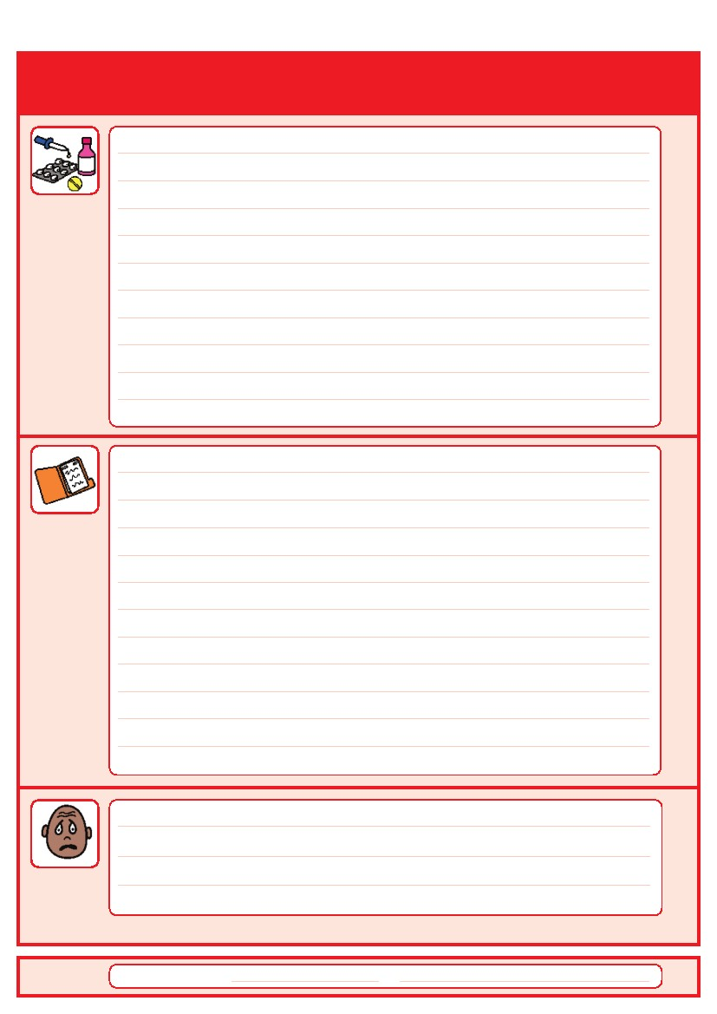
Things you must know about me
Current medication:

My medical history and treatment plan:
Date completed
What to do if I am anxious:
by
3
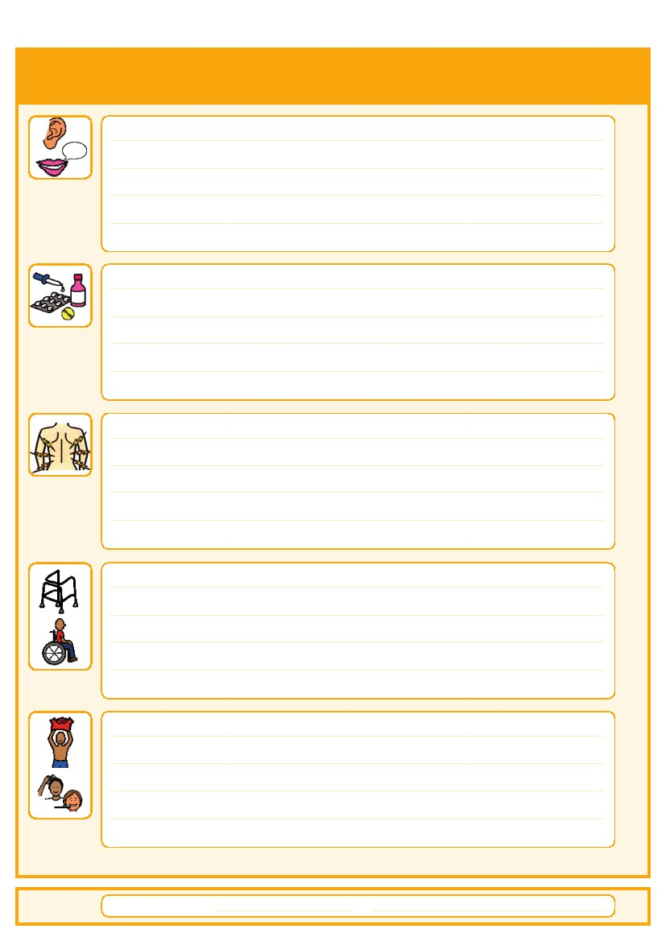
Things that are important to me
Date completed
How to communicate with me:
How I take medication: (whole tablets, crushed tablets, injections, syrup)
How you know I am in pain:
Moving around: (Posture in bed, walking aids)
Personal care: (Dressing, washing, etc)
by
4
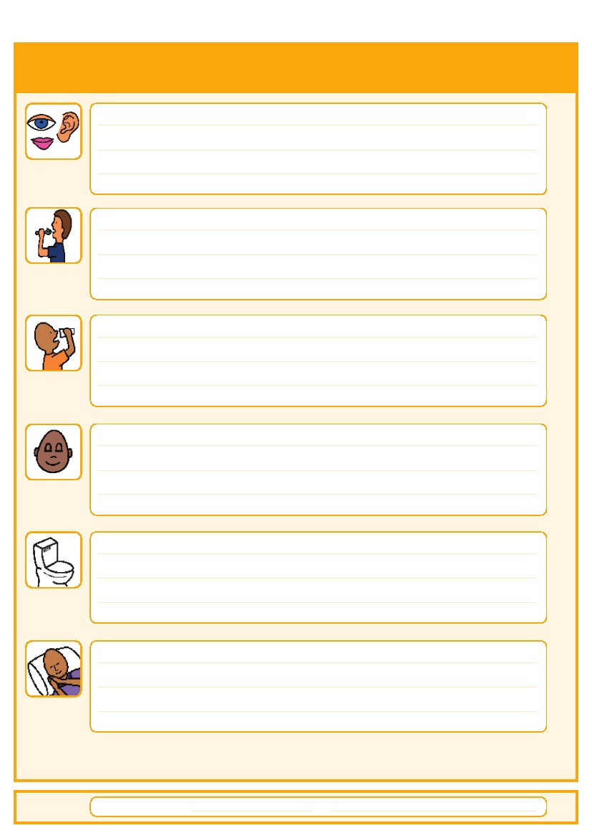
Things that are important to me
Date completed
Seeing/Hearing: (Problems with sight or hearing)
How I eat: (Food cut up, pureed, risk of choking, help with eating)
How I drink: (Drink small amounts, thickened fluids)
How I keep safe: (Bed rails, support with challenging behaviour)
How I use the toilet: (Continence aids, help to get to toilet)
Sleeping: (Sleep pattern/routine)
by
5
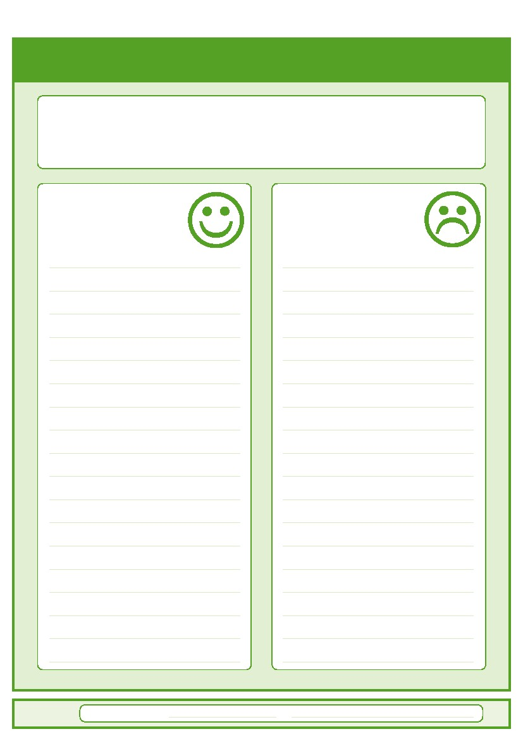
My likes and dislikes
Likes: for example - what makes me happy, things I like to do
i.e. watching TV, reading, music, routines.
Dislikes: for example - don’t shout, food I don’t like, physical touch.
Date completed
Things I like
Please do this:
Things I don’t like
Don’t do this:
by
6
7
Notes

