Caring for you and your new baby during the COVID-19 Pandemic

How do I self- isolate and keep my baby safe?
Please follow the governments’ social distancing rules but don’t hesitate to contact us if you have any concerns about yourself or your new baby.
Visits from family and friends will have to wait.

Can I still attend postnatal appointments?
Yes, making sure that you access postnatal care is really important to ensure your own and your baby’s wellbeing. Your midwife and health visitor will contact you for postnatal support. Some appointments that are usually face to face may now be over the phone. Your midwife and health visitor will advise you about this
To attend appointments in person, you must not be self-isolating because you have symptoms of the COVID-19 virus. Please advise your midwife if anyone in your household is self-isolating.

How do I know if my baby is getting ill?
Children will get sick for many reasons during the COVID-19 pandemic, we really want to know if you have any concerns about your baby. We are here for you.
If your baby is unwell the Baby Check app has 19 simple checks that you can do if their baby is showing signs of illness. If you use the app and are still worried, you should seek advice from a doctor or NHS 111.

The Baby Check app does not diagnose COVID-19 if you’re worried get advice
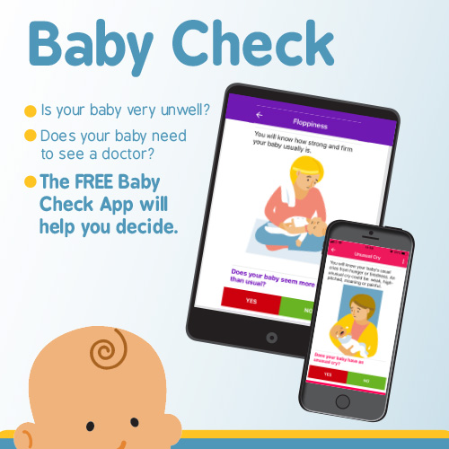

I am really worried about my baby, it is a risk taking them to a doctor or hospital because of COVID -19?
If your baby is unwell it is important to seek medical attention straight away.
If you’re worried about your baby call your GP or contact NHS 111
If you are unwell or self-isolating make the health professionals aware.

If your baby seems very unwell, is getting worse, or you think there is something seriously wrong
Call 999
Trust Your Instincts

Can I still breastfeed if I have coronavirus (COVID-19) or feel unwell?

Yes. There is no evidence showing that the virus can be carried in breastmilk. The following precautions are recommended by Royal College of Obstetricians and Gynaecologists:
- Wash your hands before touching your baby, breast pump or bottles
- Try to avoid coughing or sneezing on your baby while breastfeeding.
- Consider wearing a face mask while breastfeeding, if available
- Follow recommendations for cleaning/sterilising pumps, soothers etc.

Can I still have skin to skin contact?

Yes. It is recommended to continue with skin-to-skin contact with your baby.

Where should my baby sleep?

We would always advise that your baby sleeps in their own separate sleep place, such as a cot or Moses basket in the same room as you. If you are unwell this is very important

